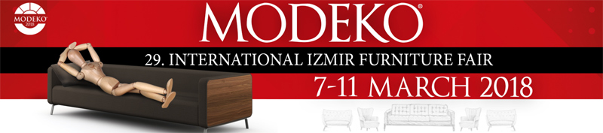
BUYER APPLICATION FORM
PERSONAL & COMPANY INFORMATION (Please complete ALL fields in capital letters):

Company Name: |  | إ  (Attach your business card)
Visitor Name: |  | إ  (Attach your business card)
Title/Profession: |  | إ  (Attach your business card)
Country: |  | إ  (Attach your business card)
Tel: Fax: |  | إ  (Attach your business card)
E-mail: |  | إ  (Attach your business card)
Website: |  | إ  (Attach your business card)
COMPANY PROFILE (please tick ALL that apply):
Wholesaler ة | Chain store | Importer | Exporter  ر | Industrial designer | Architect
Agent | Interior architect | Decorator | Furniture store | Association | Distributor
Other (Please Specify)أ

If your company is a retailer, how many shops do you have? In your country: ……. shops Abroad: ……. Shops
ا ؟
If your company is a manufacturer, how many factories do you have? In your country: ……. Abroad: ……. Factories
؟
How many employees do you have in your company?
How many countries do you cover?
Revenue (last year): ……………………… USD Revenue growth (last year/year before): ………… %

Please make a summary of your existing business activities within the furniture industry in your country and abroad.
..........................................................................................................................................................................................
INTERESTED FIELD OF ACTIVITY (please tick ALL that apply):
Modern Furnitureا  Classic Furniture  Rustic Furniture  Modular Furniture  Table, sofas, chairs and armchairs  Baby & teenage rooms furniture | Office furniture  Kitchen furniture  Garden furniture  Home decoration and accessoriesد  Lighting equipment أ  Beds and bedding ensemblesا
Others: (Please Specify) /: ....................................................................................................................................

Please complete this form and send by email to info@antexpo.com.tr!
Organizer: EFOR Fuarcılık 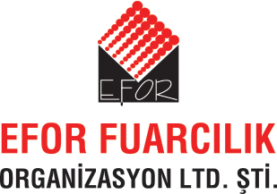    Int'l Marketing Partner: AntExpo | Contact: Rabia Alga & Burcu Emen  Tel: +90 216 541 0390 Web: www.modekofair.com

